**WINDOWS (PC) RUNNING TABPY Server in Console – see below Command lines to:**

1. **Find Taby.py file location after PIP INSTALL tabpy-server locally on computer**

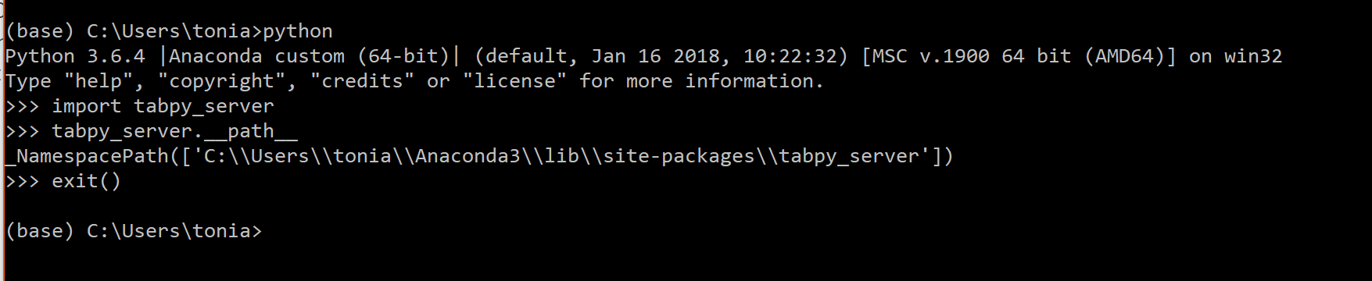

1. **Go to location of tabpy_server folder then execute following line: .\startup.bat (PC Version) or ./startup.sh (Mac Version) – below displays how to run on PC.**

